AP Physics Unit 5
Lab 5-1: Uniform Circular Motion

Introduction
The typical response when one hears the word acceleration is to think of an object changing its speed. You have also learned that velocity has both magnitude and direction. So, an object traveling at constant speed in a circular path is undergoing an acceleration. In this experiment you will develop an expression for this type of acceleration.
OBJECTIVES
In this experiment, you will
- Analyze velocity vectors of an object undergoing uniform circular motion to determine the direction of the acceleration vector at any given moment.
- Collect force, velocity, and radius data for a mass swinging as a pendulum.
- Analyze the force vs. velocity and force vs. radius graphs.
- Determine the relationship between force, mass, velocity, and radius when the force is perpendicular to the velocity.
- Use this relationship and Newton’s second law to determine an expression for centripetal acceleration.

MATERIALS
Vernier data-collection interface | string
Logger Pro or LabQuest App | ring stand or support rod
Vernier Photogate | rod to support Force Sensor
Vernier Dual-Range Force Sensor | slotted lab masses
right-angle clamp | metric tape
mass hanger

PRE-LAB INVESTIGATION
Tie something soft (such as a stopper) to a one-meter length of string. Taking care not to hit anyone nearby, swing the stopper so that it travels in a horizontal circular path over your head. Feel the tension force you must apply in order to keep the stopper moving at a nearly constant speed. Now, see what effect varying the speed of the stopper or the length of the string has on the force you apply to keep the stopper moving in a circular path. Record your observations.
Your instructor will lead a discussion that will enable you to determine the direction of the acceleration vector for an object moving at constant speed in a circular path. For this experiment, you will treat the arc of a pendulum bob as a portion of a circular path. In your pre-lab discussion, you will decide at what point in the motion of the pendulum you should record its velocity and the tension force acting on it.

PROCEDURE
1. Secure a Dual-Range Force Sensor to a support rod connected with a right angle clamp to a longer rod or ring stand, as shown in Figure 1. The sensor should be in the vertical position.
2. Tie a mass hanger to one end of a length of string (0.7 to 1.0 m) and make a loop at the other end that will allow the hanger to swing freely from the hook on the force sensor.
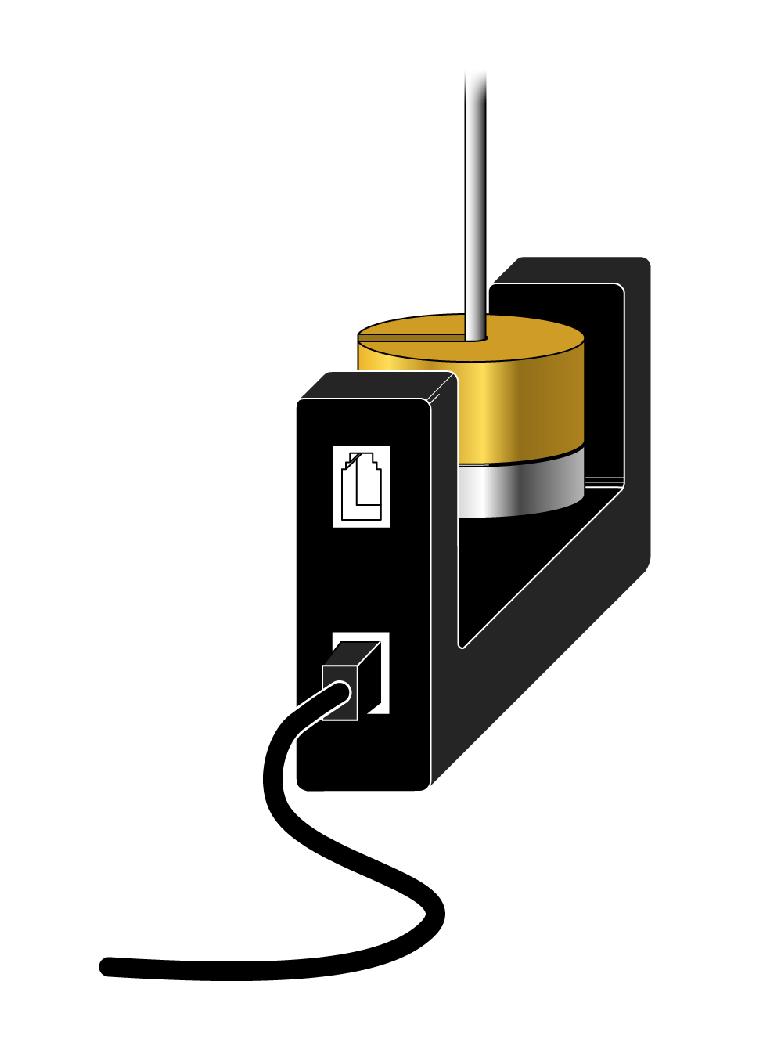
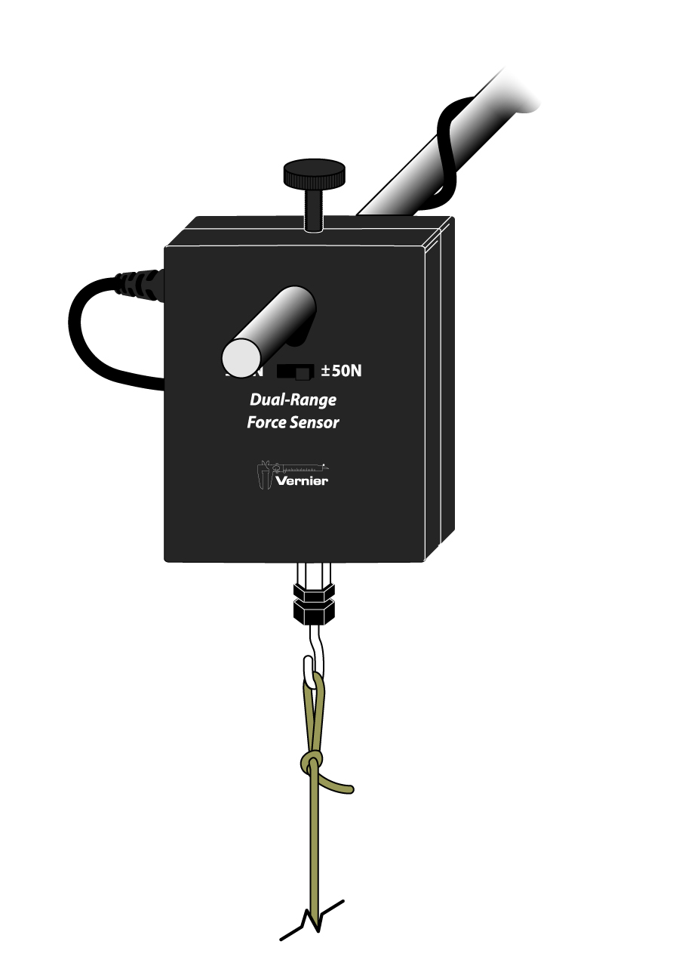
3. Place a Photogate on the floor beneath the mass hanger so that the hanger (plus the additional mass you place on it) can swing freely through the arms of the Photogate, as shown in Figure 2.
Figure 1 Figure 2
4. Connect the force sensor and the photogate to the interface and start the data-collection program.
5. Set up data collection.
Using Logger Pro
- Use time-based data-collection mode. Change the data-collection rate to 50 samples/second and the data-collection length to 10 seconds.
- Choose Set Up Sensors ►Show All Interfaces from the Experiment menu.
- Click the image of the Photogate and choose Gate Timing.
- Click again on the image of the Photogate to set the Distance or Length to the measured diameter of the object that will block the Photogate as it swings through its arms.

With either program, make the necessary adjustments so that two graphs, force vs. time and velocity vs. time, appear in the graph window.
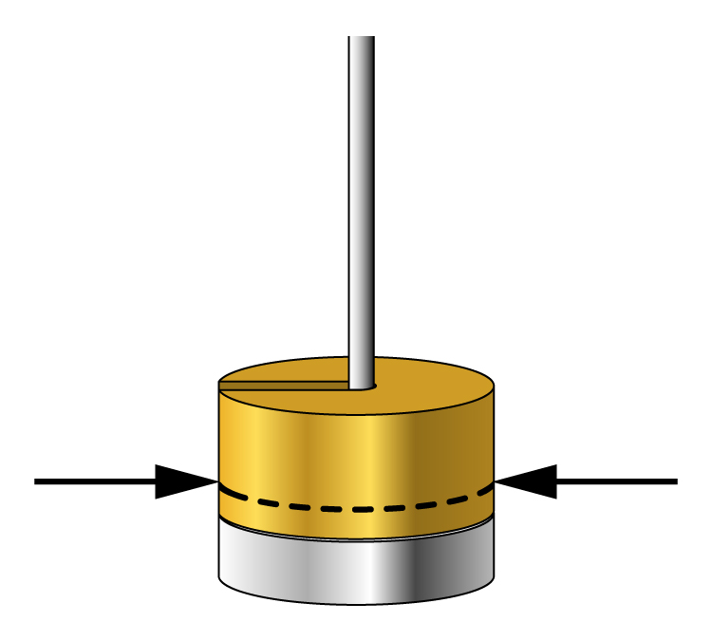
Part 1 Force vs. velocity
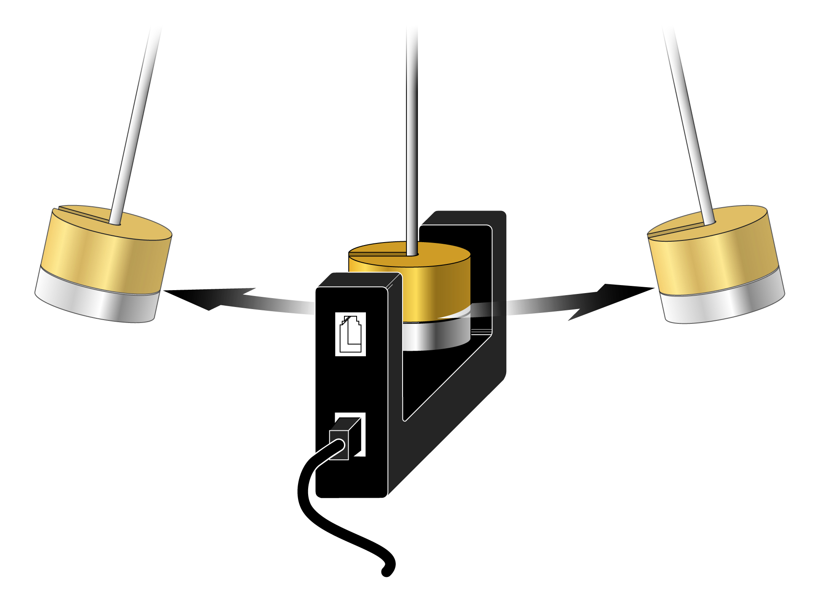
1. Record the mass of the object serving as your pendulum bob. For this experiment, we are treating the hanger and weight as an idealized bob, that is, as a point mass. Its center of mass (CM) is the position where you could theoretically balance it on your finger if it were lying sideways. Measure and record the distance from the hook on the force sensor to the center of mass of the bob that will swing through the photogate.
2. Pull the bob back 15 to 20° from its resting position and release it. If it appears to be swinging smoothly through the photogate, begin collecting data; otherwise, repeat.
3. Select a region of the force vs. time graph where the maximum force appears to be nearly constant for at least three cycles. Choose Statistics and record the maximum value of the force.
4. Choose Statistics for this same portion of the velocity vs. time graph and record the maximum velocity.
5. Repeat Steps 2–4, gradually increasing the distance you pull the object back from the vertical, until you have at least seven data points. Your final velocity reading should be at least four times as large as your initial value.
Part 2 Force vs. radius
6. Measure and record the distance from the hook on the force sensor to the center of mass of the bob that swings through the photogate. This initial value of the radius should be at least 0.9 m.
7. Pull the bob back about 15–20° from its resting position and release it. Observe the trace on the velocity vs. time graph. In order to keep the velocity relatively constant as you vary the radius, choose some value of the velocity that appears to be easily reproducible and record this value.
8. Pull the bob back as you did before and release it. When its velocity nears your target value, select a region of the force vs. time graph and record the maximum value of the force as you did in Step 3.
9. Shorten the length of string connecting your mass hanger to the force sensor, measure and record the distance from the hook on the force sensor to the center of mass of the bob.
Repeat Step 8.
10. Continue until you have at least six data points. Your minimum radius should be less than half of your starting value.

EVALUATION OF DATA
While it is possible to evaluate the data for this experiment in LabQuest App, it is easier to use Logger Pro. With LabQuest App, you should disconnect the sensors and start a new file for each part. In Logger Pro, you should disconnect the interface from the computer before starting a new file.
Part 1 Force vs. velocity
1. Start a new file and manually enter the data you have recorded.
2. Write a statement that describes the relationship between the peak tension force acting on the object and its maximum velocity.
3. If your graph of F vs. v_{max} is not linear, take steps to modify a column so as to produce a linear relationship. When you have done so, save your file and sketch your original and then linearized graph.
4. Write the equation of the line that best fits your linearized graph. Simplify the units of your slope as much as possible.
Part 2 Force vs. radius
5. Start a new file and manually enter the data you have recorded.
6. Write a statement that describes the relationship between the peak tension force acting on the object and the radius of the arc described by the swinging object.
7. If your graph of F vs. r is not linear, take steps to modify a column so as to produce a linear relationship. When you have done so, save your file and sketch your original and then linearized graph.
8. Write the equation of the line that best fits your linearized graph. Simplify the units of your slope as much as possible.
Part 3 Consolidation of your findings
9. Prepare a summary of your analysis of data (whiteboard or chart paper) for either or both parts of the experiment, as directed by your instructor. Include the original and linearized graph and the equation of the line of best fit. Also report the system mass and the value of the parameter you held constant. In your class discussion you will compare your findings with those of other groups.
10. If your linearized graphs have a relatively large vertical intercept, the relationship between the variables is not proportional. Discuss what adjustment you need to make and why this adjustment is appropriate. Open your saved files and make the necessary adjustments in order to obtain graphs depicting proportional relationships. If possible, print these graphs.
11. When a quantity (in this case, net force) is a function of more than one variable, it is usually the case that the slope of the graph is related to the parameters held constant during the experiment. Examine the units of the slope of your graph of F_{net} vs. v²; simplify these to find an expression involving these parameters. How closely does the value of this expression agree with that of the slope? From what you have learned, write an equation for the net force in terms of all three variables. Confirm this by performing a similar analysis of your
F_{net} vs. 1/r graph.
12. Use what you have learned in Step 11 and Newton’s second law to write an equation for the acceleration of the object at the point in its path when the net force acts perpendicular to the object’s velocity. Use your text or a web resource to determine the meaning of the term “centripetal.”

Extension
Wikipedia warns that the centripetal force is not to be confused with centrifugal force. It describes the latter as a fictitious or inertial force. Describe an example of such a force that you have experienced and how this interaction might better be explained in terms of centripetal force.

