AP Physics Unit 2: Kinematics—Linear Motion
Lab 2-2: Accelerated Motion
Purpose:
When you examined an object moving with constant velocity in Lab 2.1, you learned two important points about the line of best fit to the graph of position vs. time:
1. The slope (rate of change) of the graph was constant, and gave the velocity of the object.
2. The intercept gave the initial position of the object.
In this experiment, you will examine a different kind of motion and contrast features of the position-time and velocity-time graphs with those you have studied earlier.

MATERIALS:
Vernier data-collection interface | standard cart
Logger Pro or LabQuest App | Motion Detector bracket
Vernier Motion Detector | books or blocks to elevate track
Vernier Dynamics Track

PRE-LAB INVESTIGATION:
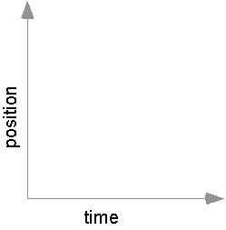
Elevate one end of the track. Place the cart at the lower end and give it a gentle push so that it moves up the track (without falling off) and returns to its starting position.
On the axes to the right, predict what a graph of the position vs. time would look like. Use a coordinate system in which the origin is on the left and positive is to the right.

PROCEDURE:
1. Connect the Motion Detector to the interface and start the data-collection program. Two graphs: position vs. time and velocity vs. time will appear in the graph window. For now, hide or remove the velocity vs. time graph. Later, during the analysis of data, you will add the v-t graph back to your view.
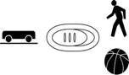
2. Attach the motion detector to the bracket that will allow you to position it near one end of the track.
3. If your motion detector has a switch, set it to Track.
4. Elevate the end of the track opposite the motion detector as directed by your instructor.
5. Practice launching the cart with your finger so that it slows to a stop at least 50 cm from its initial position before it returns to the initial position.
6. Hold the cart steady with your finger at least 20 cm from the motion detector, then zero the motion detector.
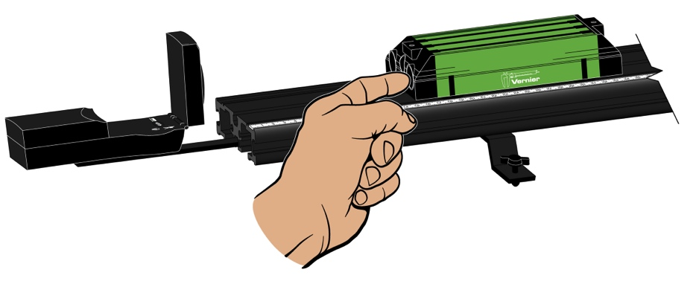

Figure 1
7. Begin collecting data, then launch the cart up the ramp. Be sure to catch it once it has returned to its starting position.
8. Repeat, if necessary, until you get a trial with a smooth position-time graph.

EVALUATION OF DATA
Part 1
1. Either print or sketch the position vs. time (x-t) graph for your experiment. On this graph identify:
- Where the cart was rolling freely up the ramp
- Where the cart was farthest from its initial position
- Where the cart was rolling freely down the ramp

2. In your investigation of an object moving at constant velocity, you learned that the slope of the x-t graph was the average velocity of the object. In this case, however, the slope for any interval on the graph is not constant; instead, it is constantly changing. Based on your observations, sketch a graph of velocity vs. time corresponding to that portion of the x-t graph where the cart was moving freely.
3. Now, view both the position vs. time and velocity vs. time graphs. Compare the v-t graph to the one you sketched in Step 2.
4. Take a moment to think about and discuss how you could determine the cart’s velocity at any given instant.
5. If you are using Logger Pro, group the two graphs (x-axis), and turn on the Tangent tool for the x-t graph and the Examine tool for the v-t graph. (In LabQuest App, simply turn on the Tangent tool). Using either program, compare the slope of the tangent to any point on the x-t graph to the value of the velocity on the v-t graph. Write a statement describing the relationship between these quantities.
Part 2
1. Perform a linear fit to that portion of the v-t graph where the cart was moving freely. Print or sketch this v-t graph. Write the equation that represents the relationship between the velocity and time; be sure to record the value and units of the slope and the vertical intercept.
On this v-t graph identify:
- Where the cart was being pushed by your hand
- Where the cart was rolling freely up the ramp
- The velocity of the cart when it was farthest from its initial position
- Where the cart was rolling freely down the ramp

2. The slope of a graph represents the rate of change of the variables that were plotted. What can you say about the rate of change of the velocity as a function of time while the cart was rolling freely? In your discussion, you will give a name to this quantity. What is the significance of the algebraic sign of the slope?
3. Compare the value of your slope to those of others in the class. What relationship appears to exist between the value of the slope and the extent to which you elevate the track?
4. The vertical intercept of the equation of the line you fit to the v-t graph represents what the velocity of the cart would have been at time t = 0 had it been accelerating from the moment you began collecting data. Suggest a reasonable name for this quantity. Now write a general equation relating the velocity and time for an object moving with constant acceleration
5. The position-time graph of an object that is constantly accelerating should appear parabolic. Use the Curve Fit function of your data analysis program to fit a quadratic equation to that portion of the x-t graph where the cart was moving freely. Note the values of the A and B parameters in the quadratic equation. You will have to provide the units.
6. Compare these parameters (values and units) to the slope and intercept of the line used to fit the v-t graph. Now write a general equation relating the position and time for an object undergoing constant acceleration.

If you are using an older motion detector without a switch, the cart needs to be at least 45 cm from the detector.

