AP Physics Unit 1: Physics Tool Kit
Lab 1-2: Introduction of Laboratory Hardware

Purpose:
The study of how things move and why they move is an important part of an introductory physics course. The use of technology greatly aids the collection and analysis of data. In this activity you will have the opportunity to learn how to use a Motion Detector to examine aspects of the motion of an object. The motion detector works by emitting and detecting ultrasound. It generates a series of ultrasound pulses, and then detects the echoes returning from an object. The time between the emitting of a pulse and the reception of its echo is used to calculate the position of the object using the speed of sound. Position and time data are then used in software to determine the velocity of the object.
The Vernier Photogate is used to collect a wide variety of motion data. It can also be used to study the motion of toy cars, dynamics carts, objects in freefall, pendulums, projectiles, and much more.
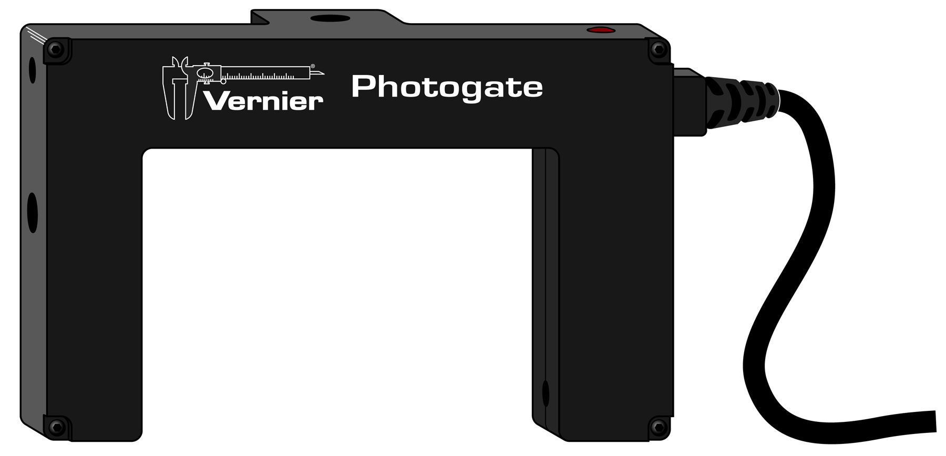
The photogate works by projecting an infrared beam from one arm of the sensor to the other arm. When the beam is blocked the sensor sends a signal, which illuminates an LED on the top of the gate as well as triggering the software to display a blocked message in the data-collection area.
Photogates measure times at which the gate is blocked or unblocked. There are several ways of using this timing information, depending on the goal of your experiment.
- If you need to know timing information from a pulley or a picket fence object, you will need “Motion Timing.” Motion timing uses the block-to-block timing of regularly spaced marks and can be use to generate position, velocity and acceleration graphs.
- If you have an object passing through a gate, and you want to know its speed, you need “Gate” timing. Gate timing measures the block-to-unblock time interval; the ratio of the object length and the time interval is the object’s speed.
- If you have an object passing from one photogate to another you will need “Pulse Timing.” Pulse timing measures the block-to-block time for a pair of gates. For example, you might measure the average speed of a cart passing through one gate and then through a second gate. The ratio of the gate spacing and the block-to-block time is the cart’s speed. Pulse timing is not used in this book.
- If you need to measure the period of a pendulum, which is the time from the first to the third block of a photogate, you need “Pendulum Timing.”
There are also other, less common timing modes. The default timing mode is Motion Timing.
This tutorial shows you some of the ways you can use the Vernier Photogate to collect data. Refer to the part you need for the specific application in your experiment.
Available Materials for Use:

- Logger Pro
- Motion Detector
- Detector Bracket
- Cart
- Track
- Cart Picket Fence

- Picket Fence

part 1 – Motion Detector
Procedure:
1. Connect the Motion Detector to the interface and start the data-collection program. Two graphs: position vs. time and velocity vs. time will appear in the graph window. For now, you need only consider the position vs. time graph.
- In Logger Pro, delete the velocity graph, then choose Auto Arrange from the Page menu.

Later, during the analysis of data, you will add the velocity vs. time graph back to your view.
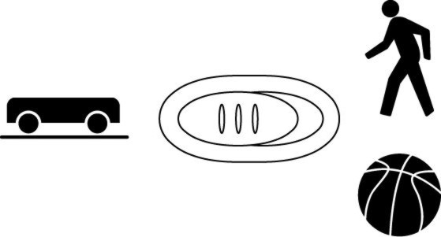
2. Attach the motion detector to the bracket that will allow you to position it near one end of the track.
3. If your motion detector has a switch, set it to the Track setting.
4. Place the cart approximately 20 cm in front of the motion detector. The live readout on the display in Logger Pro will tell you the position of the cart. Note the position of the back end of the cart on the scale on the track.
5. Position the end stop on the track so that when the cart runs into it, the cart will have moved a known distance (~70–85 cm) from its initial position (see Figure 1).
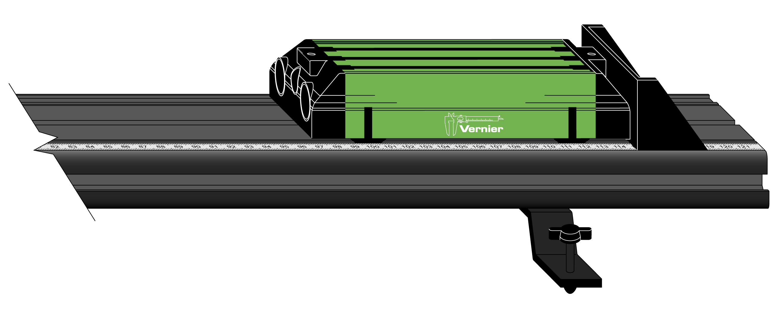
Figure 1
6. Return the cart to its original position near the motion detector. Start data collection, then, once you hear the motion detector clicking, give the cart a gentle push. Data collection stops automatically after 5 seconds.
7. The motion detector sends out its signal in a cone, and it detects the first echo from the nearest object in the cone. This object may or may not be the object of interest. Examine the position vs. time graph. If there are jagged dips in the graph once the cart began moving, it could be that your hand or some other object was picked up by the motion detector. If this is the case, repeat Step 6, but be sure that your hand or other stray objects do not interfere with the signal returned by the cart. If you have a smooth graph, store this run.
- In Logger Pro, choose Store Latest Run from the Experiment menu.

8. Repeat Step 6, but this time, launch the cart somewhat faster than you did the first time. If you have a smooth graph, store this run. Note differences in the appearance of the position-time graph for the two runs. You will examine this in greater detail in the Evaluation of Data section.
Zeroing the motion detector
9. In the analysis of position-time (x-t) data it is convenient to consider the initial position as zero. This can be done with the motion detector. Place the cart at the starting position you used in the previous run, then zero the detector.
- In Logger Pro, choose Zero from the Experiment menu.

10. Repeat Step 6, then store this run as before. Compare the x-t graph for this run to that obtained in your previous runs.
Reversing the detector
11. Now, position the cart at the far end of the track. Start data collection, then give the cart a gentle push toward the motion detector. Be sure to catch the cart before it runs into the detector. If your x-t graph is smooth, store this run.
12. The default setting for the motion detector is to designate the direction of motion away from the detector as positive. In this run, the object was moving in the opposite direction; note that the x-t graph has a positive vertical intercept and a negative slope. It is sometimes useful to consider the direction of motion as positive. You can set the motion detector to treat motion toward the detector as positive.
- In Logger Pro, choose Set Up Sensors from the Experiment menu, then select your interface (LabQuest, Lab Pro, etc.). Click the icon representing the motion detector and choose Reverse Direction in the pop-up dialogue box, then close the box.

13. Now, position the cart at the far end of the track. Zero the motion detector as you did in Step 9, then give the cart a gentle push toward the detector. Be sure to catch the cart before it runs into the detector. If your x-t graph is smooth, store this run. Compare the appearance of your x-t graph to that obtained in the previous run. You need not store this run; however, you should save this experiment file.
Data Analysis:
1. Examine the position vs. time graph for your first run.
- In Logger Pro, the color of the entries in the data table matches the trace of the line in the graph. You can choose to view only one run by clicking the vertical axis label, choosing More, then selecting Position for the run of interest and de-selecting the other runs.
- In LabQuest App, you can choose to view any of your four runs by tapping on the number for that run.

2. Determine the rate of change of position of the cart while it was moving at nearly constant speed. To do this, select the portion of the graph in which the plot appears linear by dragging your cursor (or stylus) across this region. Then perform a linear fit on that portion of the graph.
- In Logger Pro, choose Linear Fit from the Analyze menu. You can adjust the segment over which the linear fit was performed by dragging the bounds, marked by [ and ] symbols.
3. What information about the motion of the cart is provided by the slope of the graph? How do the units confirm your answer?
4. Now choose to view the position vs. time graph for your second run. Explain how you can tell, by looking at the graph alone, how the speed of the cart compares to that in the first run. Now, repeat Step 2 and compare the value of the slope of the linear region to that obtained for your first run.
5. Now choose to view the position vs. time graph for the run in which you first launched the cart toward the motion detector (Run 4). What is the significance of the sign of the slope of the linear portion of this graph?
6. Now return to your first run. Choose Velocity as the vertical axis label. How does the plot of velocity vs. time correspond to the motion that you observed? Can you account for the fact that the plot may not be entirely horizontal?
7. Select an interval during which the velocity was nearly constant by dragging your cursor (or stylus) across this region. Choose Statistics from the Analyze menu. Note: Either application will display a number of statistical measures relating to velocity over this interval. From the information provided determine the percent decrease in the velocity over this interval.
8. In addition to slope, the area under a curve often has physical meaning. To determine the area, select the portion of the graph corresponding to when the cart was moving, then choose Integral from the Analyze menu.
9. What are the units of the area under the curve? What information about the motion of the cart does the area provide?

part 2 – Motion timing
Procedure:
When you start the data-collection software, the default mode for the photogate is Motion Timing. In this mode the software records a series of blocking events from an object that has a repeating transparent and opaque pattern.
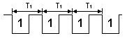
Two good examples of objects that utilize this mode are the Vernier Picket Fence (a plastic bar with a series of opaque and transparent bars) or the Vernier Ultra Pulley.
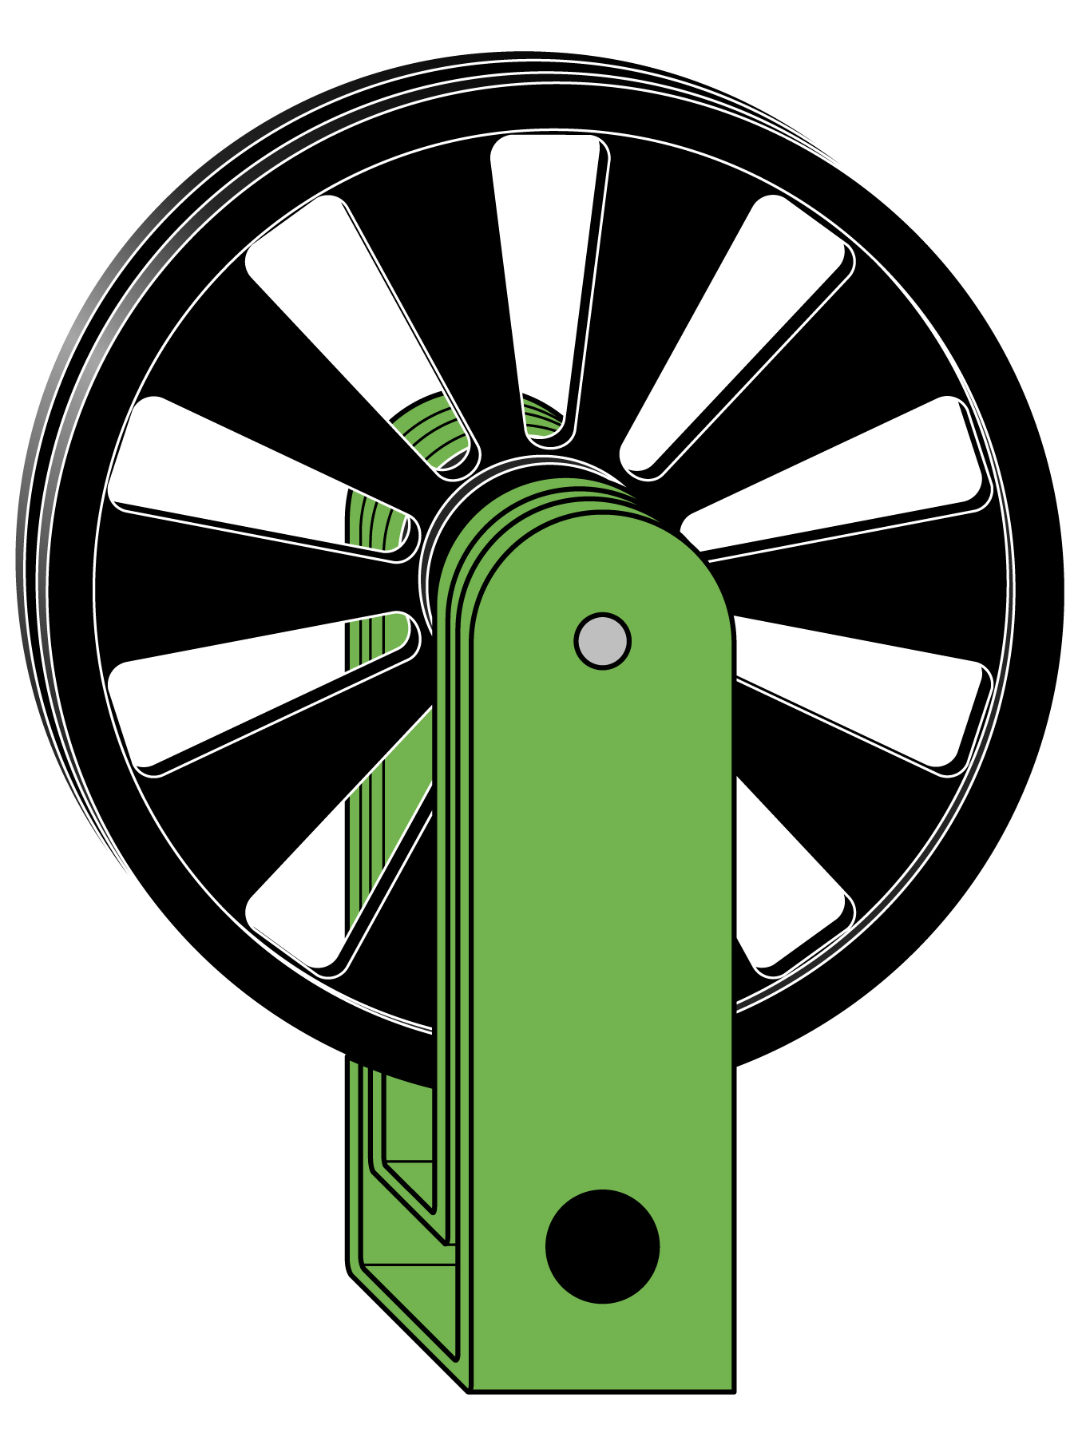
When a picket fence (see right) passes completely through a photogate, the equipment records eight blocking events, one for each black bar. The distance from the leading edge of one black bar to the next is 5 cm. Using the times from the blocking events and the 5 cm spacing, position, speed and acceleration data are determined. A smaller version of this picket fence is available for use on dynamics carts. The spacing between leading edges of the black bars on the smaller fence is 1 cm.
If you are using a pulley instead (see right), the pulley spokes block and unblock the beam. Using the blocking times and knowing the circumference of the pulley, the software can again determine position, speed and acceleration. A good example of the use of the pulley is with an Atwood’s machine.
Using Logger Pro
1. Connect a Vernier Photogate to the interface and start Logger Pro.
2. Verify that the photogate and software are working by placing your hand in the photogate beam. The red LED on the top of the gate should illuminate and the software should display Blocked next to GateState above the data table in the data-collection area. If this does not happen, check all of your connections.
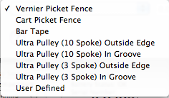
3. From the Experiment menu choose Set Up Sensors, specify your interface, then click on the icon of the photogate in the window. Note that Motion Timing is the default mode. When you select Set Distance or Length you can choose from a number of pre-set values or choose your own length by selecting User Defined (see right). The value and unit entered determine the steps in the distance column, which in turn scales the velocity and acceleration columns.
4. Begin collecting data, then, holding a picket fence by the edge, pass it through the photogate in a steady motion. Then stop collecting data. This can be accomplished either by clicking the Stop button or by pressing the spacebar.
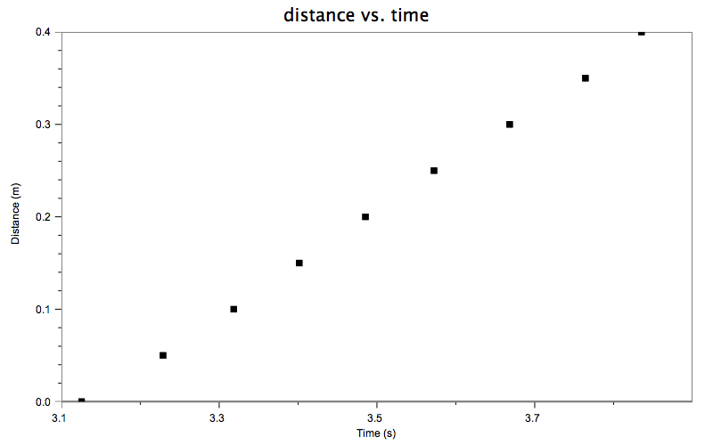
5. An examination of the graph of distance vs. time shows that the picket fence was moving at nearly constant velocity (see Figure 1).

Figure 1
part 3 – gate timing
Procedure:
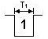
Gate timing begins when the photogate is first blocked. The timing continues until the gate is unblocked. The duration of the interruption is recorded by the software. If the length of the object is entered in the Length of Object field, the speed is calculated. The diagram at right represents the gate state during a blocking event. Initially the gate is unblocked, then blocked, and then unblocked again.
Speed calculation in Gate mode relies upon knowing the length of the object going through the gate. For some objects (the flag on the cart picket fence or note cards) this is not a problem, but other objects might be more challenging. For example, if you rolled a marble through the gate, you would need to know the diameter of the ball that went through the beam. Inaccuracies in positioning the photogate can introduce errors into the speed measurements; therefore, alignment in this type of experiment is important.
When using the Gate mode, you can also add a second photogate to measure the speed of an object through that gate. Use of two photogates in this mode would allow you to determine the change in the speed of a single object or to determine the speed of two objects.
Using Logger Pro
1. Connect a Vernier Photogate to the interface and start Logger Pro.
2. Verify that the photogate and software are working by placing your hand in the photogate beam. The red LED on the top of the gate should illuminate and the software should display Blocked next to GateState above the data table in the data-collection area. If this does not happen, check all of your connections.
3. From the Experiment menu choose Set Up Sensors, specify your interface, then click on the icon of the photogate in the window. Select Gate Timing as the mode.
4. Click on the icon of the photogate again and select Set Distance or Length. Note that the default setting is 0.050 m. This is the width of the flag on the cart picket fence. Choose an object (your finger, a ruler, etc.) you can use to block the beam. Measure its width, then set the distance to that value.
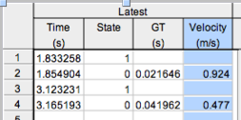
5. Begin collecting data, pass the object slowly through the photogate, then back through the beam again, then stop the data-collection. Examine the data table. You should see something like that in Figure 3.

Figure 3
The time column indicates when the beam was blocked (State = 1) and then unblocked
(State = 0). The GT (Gate Time) column displays the duration. The Velocity is calculated from the distance you set and the duration of the block. These data show that the object moved more slowly in the second pass through the photogate than in the first.
Part 4 – pendulum Timing
Procedure:
The Pendulum Timing mode uses a single photogate attached to an interface. The timing will begin when the photogate is first interrupted. The timing will continue until the photogate is interrupted twice more, so that you get the time for a complete swing of a pendulum or other oscillating object.
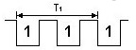

Use of this mode will give you very accurate measurements of pendula periods.
Using Logger Pro
1. Connect a Vernier Photogate to the interface and start Logger Pro.
2. Verify that the photogate and software are working by placing your hand in the photogate beam. The red LED on the top of the gate should illuminate and the software should display Blocked next to GateState above the data table in the data collection area. If this does not happen, check all of your connections.
3. From the Experiment menu choose Set Up Sensors, specify your interface, then click on the icon of the photogate in the window. Select Pendulum Timing as the mode.
4. Move your finger through the photogate, count “one thousand one”, move your finger back through the photogate, count “one thousand one” again and now pass your finger back through the gate a third time. Stop collecting data. The period of this motion is displayed in the third column of the data table. This value should be close to 2 seconds if your timing was correct.
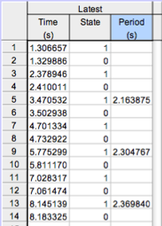
5. Try collecting data again, but this time move your finger through the photogate several times in a consistent back and forth motion. Stop collecting data. Judge how uniform was the period of your “pendulum motion” (see Figure 5).

Figure 5

If you are using an older motion detector without a switch, the cart needs to be at least 45 cm from the detector.
This distance will be less if you are using an older motion detector.

