Name:
Date:
Final Review: Electrostatics

- A neutral rod accumulates a negative charge when it is rubbed with animal fur (aka charged by friction). It can be said that
  - The protons were transferred from the rod to the animal fur thus making the rod negatively charged, and the fur positively charged.
  - The electrons were transferred from the rod to the animal fur thus making the rod negatively charged and the fur positively charged.
  - The protons were transferred from the animal fur to the rod thus making the rod negatively charged, and the fur positively charged.
  - The electrons were transferred from the animal fur to the rod thus making the rod negatively charged, and the fur positively charged.

- The picture below shows a charged rod being held over a once neutral metallic plate. It can be said that the plate becomes positively charged through what charging method?

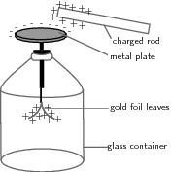

  - Conduction
  - Induction
  - Friction
  - Convection

- If the rod from question two touches the metallic plate of the electroscope, the metal plate will end up____.
  - Neutral
  - Negative
  - Positive
  - No charge

- If the rod from question two touches the metal part of the electroscope, it can be said that the electroscope was charged by_________.
  - Conduction b. induction c. friction

- It can be said that two charges
  - Will always be attracted to one another.
  - Will always be repelled by one another.
  - Will be able to attract some charges and repel others.
  - Will not interact with other charges.

- According to the below electric field diagram, the left charge is ___________ and the right charge is ___________.

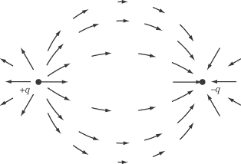

  - positive, positive
  - positive, negative
  - negative , negative
  - negative, positive

- To charges, 3 C and -2 C, are separated by a distance of 7mm. The two charges are….
  - attracted to each other.
  - repelled by each other.
  - not interacting with each other.
  - none of the above!

- If the distance between the two charges in question seven is doubled. The force between the two charges will….
  - double. b. half. C. quadruple. Quarter.

- Find the force of attraction between a 3.7µC charge and a 4.2µC charge that is separated by a distance of 3 cm.
  - 1.5 x 10¹⁰ N
  - 1.55 x 10³ N
  - 4.66 x 10⁻⁶ N
  - 1.55 x 10⁻⁸ N

- A good insulator has ________ electrons; a good conductor will have _______ electrons.
  - loosely bound, tightly bound
  - tightly bound, loosely bound
  - loosely bound, loosely bound
  - tightly bound, tightly bound

