AP Physics Test
Unit 4: Newton’s Laws
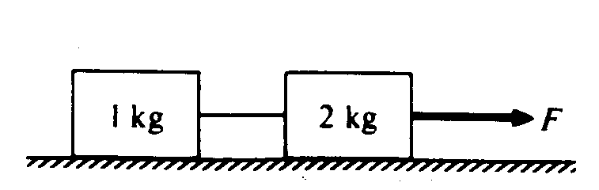
Multiple Choice. Practice spending 1 min & 15 sec per MC question!
1. (1984, 9) When the frictionless system shown is accelerated by an applied force of magnitude F, the tension in the string between the blocks is
A) 2 F B) F C) (2/3) F D) ½ F E) (1/3) F

2. (1984, 32) A 100-newton weight is suspended by two cords as shown in the figure. The tension in the slanted cord is
A) 50 N B) 100 N C) 150 N D) 200 N E) 250 N

3. (1988, 4) A particle of mass m moves along a straight path with a speed v defined by the function
v = bt² + c, where b and c are constants and t is time. What is the magnitude F of the net force on the particle at time t = t₁ ?
A) bt₁ ² + c B) 3mbt₁ + 2c C) mbt₁ D) mbt₁ + c E) 2mbt₁
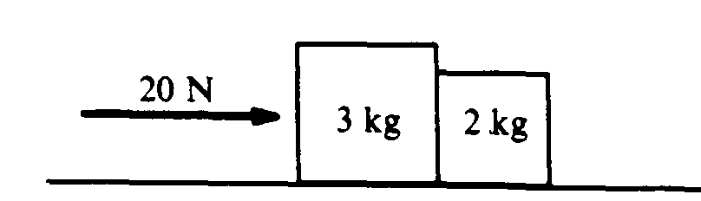

4. (1988, 29) Two blocks are pushed along a horizontal frictionless surface by a force of 20 Newtons to the right, as shown. The force that the 2-kilogram block exerts on the 3-kilogram block is
A) 8 N to the left B) 8 N to the right C) 10 N to the left D) 12 N to the right E) 20 N to the left
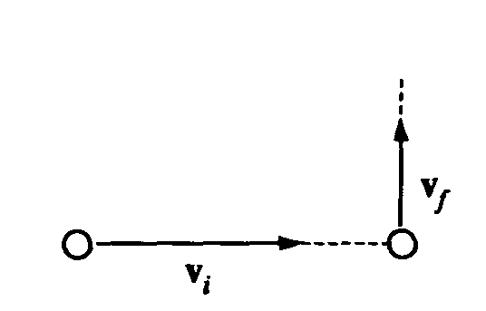

5. (1993, 4) A ball initially moves horizontally with velocity v_{i}, as shown. It is then struck by a stick. After leaving the stick, the ball moves vertically with a velocity v_{f}, which is smaller in magnitude than v_{i}. Which of the following vectors best represents the direction of the average force that the stick exerts on the ball?
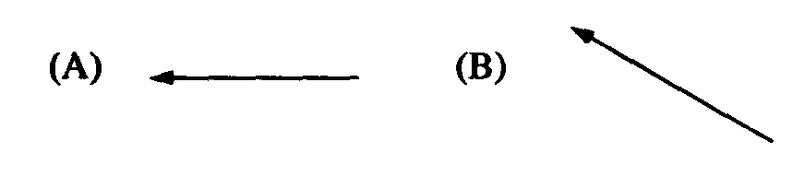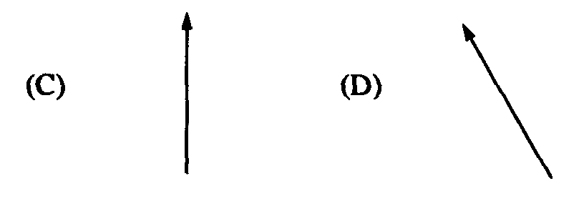
6. (1993, 5) If F₁ is the magnitude of the force exerted by the Earth on a satellite in orbit about the Earth and F₂ is the magnitude of the force exerted by the satellite on the Earth, then which of the following is true?
A) F₁ is much greater than F₂. B) F₁ is slightly greater than F₂. C) F₁ is equal to F₂.
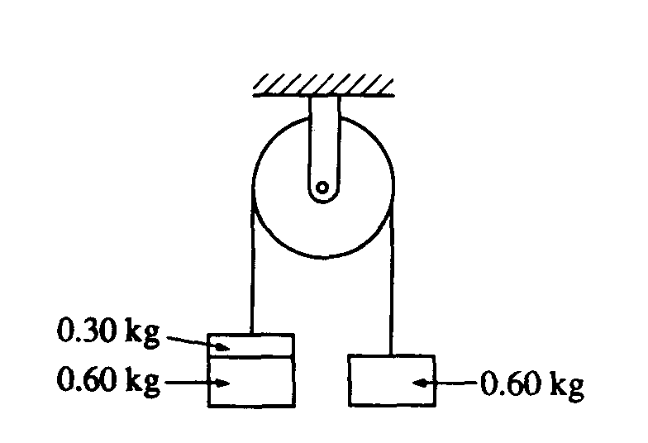
D) F₂ is slightly greater than F₁ E) F₂ is much greater than F₁

7. (1993, 9) Two 0.60-kilogram objects are connected by a thread that passes over a light, frictionless pulley, as shown. The objects are initially held at rest. If a third object with a mass of 0.30 kilogram is added on top of one of the 0.60-kilogram objects as shown and the objects are released, the magnitude of the acceleration of the 0.30-kilogram object is most nearly
A) 10.0 m/s² B) 6.0 m/s² C) 3.0 m/s² D) 2.0 m/s² E) 1.0 m/s²

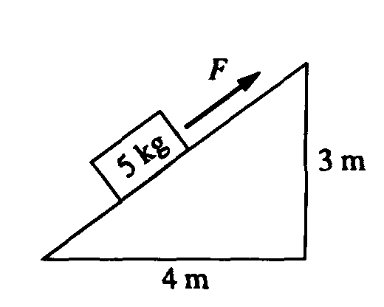
8. (1993, 34) A block of mass 5 kilograms lies on an inclined plane, as shown. The horizontal and vertical supports for the plane have lengths of 4 meters and 3 meters, respectively. The coefficient of friction between the plane and the block is 0.3. The magnitude of the force F necessary to pull the block up the plane with constant speed is most nearly
A) 30 N B) 42 N C) 49 N D) 50 N E) 58 N
9. (1998, 19) A descending elevator of mass 1,000 kg is uniformly accelerated to rest over a distance of 8 m by a cable in which the tension is 11,000 N. The speed v_{i} of the elevator at the beginning of the 8 m descent is most nearly
A) 4 m/s B) 10 m/s C) 13 m/s D) 16 m/s E) 21 m/s

Free Response. Choose any TWO. Be sure to show ALL your work!
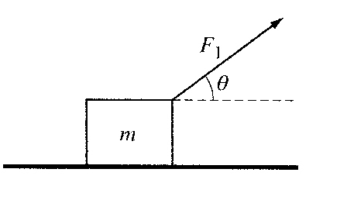
10. (2007, 1) A block of mass m is pulled along a rough horizontal surface by a constant applied force of magnitude F₁ that acts at an angle θ to the horizontal, as indicated above. The acceleration of the block is a₁. Express all algebraic answers in terms of m, F₁, θ, a₁ and fundamental constants.

A) Draw and label a free-body diagram (without components) showing all the forces on the block.

B) Derive an expression for the normal force exerted by the surface on the block.

C) Derive an expression for the coefficient of kinetic friction μ between the block and the surface.

D) Sketch graphs of the speed v and displacement x of the block as functions of time t if the block started from rest at x = 0 and t = 0.

E) If the applied force is large enough, the block will lose contact with the surface. Derive an expression for the magnitude of the greatest acceleration a_{rnax} that the block can have and still maintain contact with the ground.

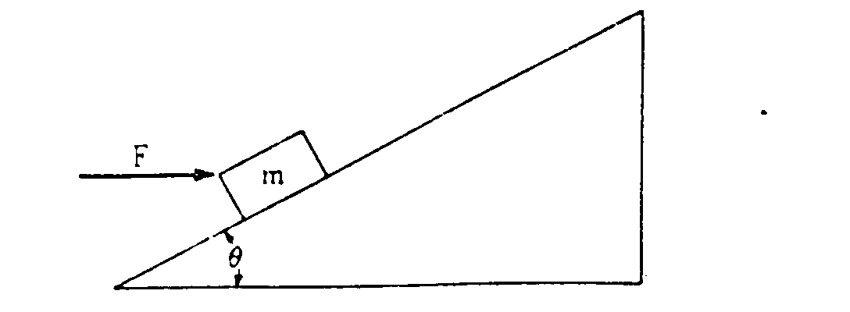
11. (1981, 1) A block of mass m, acted on by a force of magnitude F directed horizontally to the right as shown above, slides up an inclined plane that makes an angle θ with the horizontal. The coefficient of sliding friction between the block and the plane is μ.

A) Draw and label all the forces that act on the block as it slides up the plane.

B) Develop an expression in terms of m, θ, F, μ, and g, for the block’s acceleration up the plane.

C) Develop an expression for the magnitude of the force F that will allow the block to slide up the plane with constant velocity. What relation must θ and μ satisfy in order for this solution to be physically meaningful?

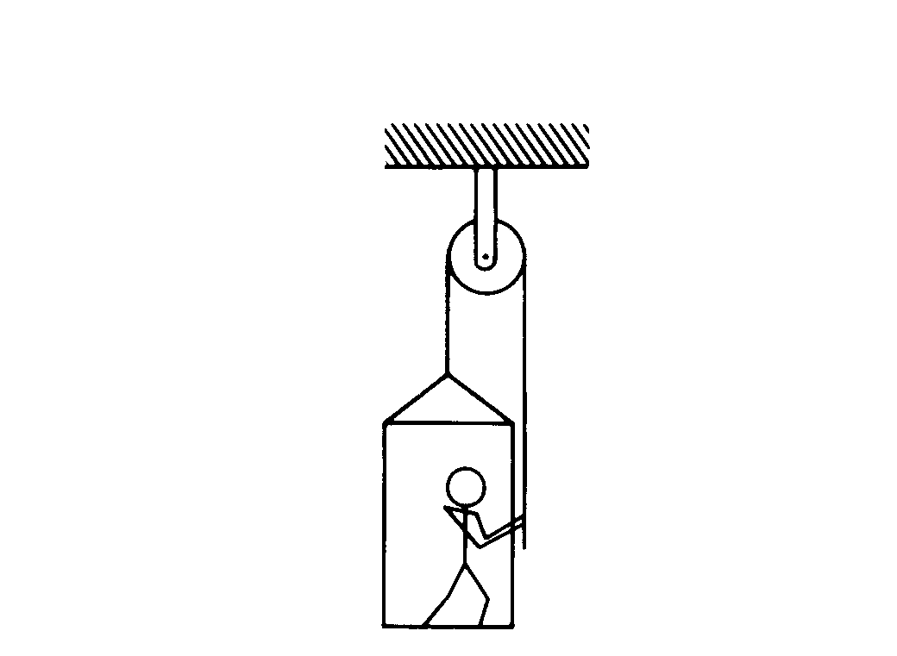

12. (1986, 1) The figure above shows an 80-kilogram person standing on a 20-kilogram platform suspended by a rope passing over a stationary pulley that is free to rotate. The other end of the rope is held by the person. The masses of the rope and pulley are negligible. You may use g = 10 m/ s². Assume that friction is negligible, and the parts of the rope shown remain vertical.
A) If the platform and the person are at rest, what is the tension in the rope?

The person now pulls on the rope so that the acceleration of the person and the platform is 2 m/s² upward.
B) What is the tension in the rope under these new conditions?

C) Under these conditions, what is the force exerted by the platform on the person?

D) If the initial velocity was zero, how fast would the platform be going after accelerating for 4 m?

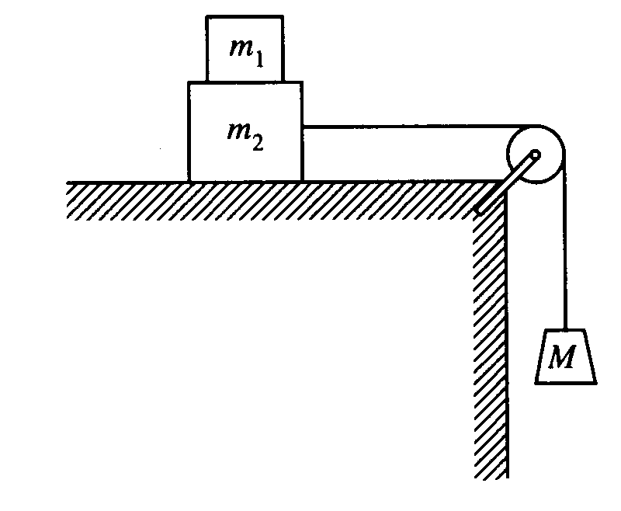
13. (1998,3) Block 1 of mass m₁ is placed on block 2 of mass m₂, which is then placed on a table. A string, connecting block 2 to a hanging mass M, passes over a pulley attached to one end of the table, as shown above. The mass and friction of the pulley are negligible. The coefficients of friction between blocks 1 and 2 and between block 2 and the tabletop are nonzero and are given in the following table.
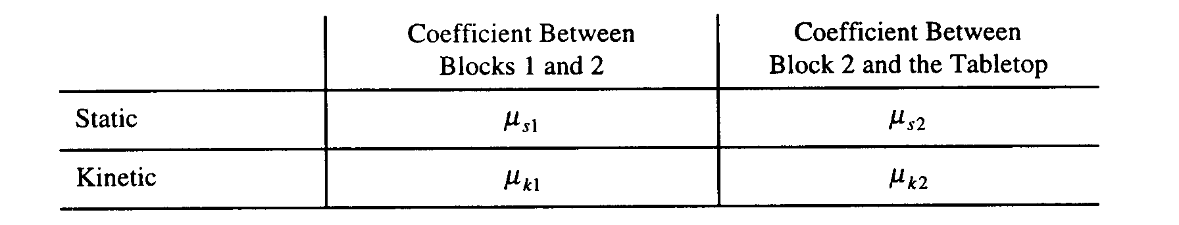
Express your answers in terms of the masses, coefficients of friction, and g.

A) Suppose that the value of M is small enough that the blocks remain at rest when released. For each of the following forces, determine the magnitude of the force and draw a vector on the block provided to indicate the direction of the force if it is nonzero.
i. The normal force N₁ exerted on block 1 by block 2

ii. The friction force f₁ exerted on block 1 by block 2

iii. The force T exerted on block 2 by the string

iv. The normal force N₂ exerted on block 2 by the tabletop

v. The friction force f₂ exerted on block 2 by the tabletop

B) Determine the largest value of M for which the blocks can remain at rest.

C) Now suppose that M is large enough that the hanging block descends when the blocks are released. Assume that blocks 1 and 2 are moving as a unit (no slippage). Determine the magnitude a of their acceleration.

D) Now suppose that M is large enough that as the hanging block descends, block 1 is slipping on block 2.
i. Determine the magnitude a₁ of the acceleration of block 1.
ii. Determine the magnitude a₂ of the acceleration of block 2.

