Timely Bouncing

Gee Idunno
Ima Student, Ortho Partner
1st Period, August 25, 2012

Purpose:
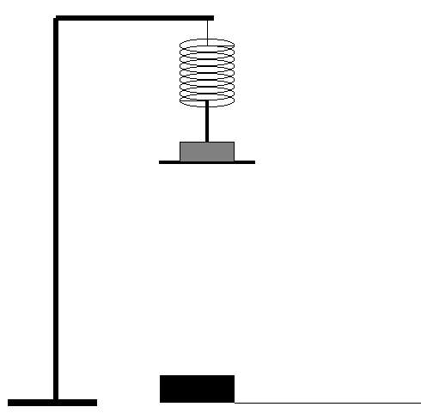
The purpose of this experiment was to determine the relationship between the mass hung on a spring and the Period of oscillation (the amount of time it takes to bounce up and down).

Materials:
Support/Stand
Clamps
Masses for hanging on spring
Ruler
Motion Sensor

Procedure:
Part 1
1. Determine the spring constant k of the spring by allowing it to hang freely and measuring its displacement x relative to its equilibrium position. The value mg/x will give you the spring constant in N/m.

2. Accurately measure the mass of the object and attach it to one end of the spring.

3. Prepare the motion sensor, placing it below the mass, and set it to pendulum/oscillation mode.

4. Do not switch springs between this part of the experiment, as k is being controlled.

5. From a height, gently let the mass fall after clicking “Collect” on the LoggerPro program. Using the sinusoidal graph on the screen, determine the amount of time it takes to complete one full oscillation. This is the period T of the oscillation. Repeat this 3 or 4 times to obtain an average. Record both the mass m and the period T in a table.

6. Use different masses and repeat the above step, while making sure not to switch springs in between (in order to keep k constant). Record mass-period pair values for each different mass used.

7. With the above data, graph a mass versus period and a spring-constant versus period graph. Analyze the resulting two graphs and their shapes. Explain the relationship between the mass m and the period T of the oscillating mass, and the relationship between the spring-constant k and the period T of the oscillating mass.

Data:
Table 1. Spring Constant Calculation
Δ Length (m) | Mass (kg) | Spring Force (N)
0.03 | 0.10 | 1.0
0.7 | 0.20 | 2.0
0.10 | 0.30 | 3.0
0.13 | 0.40 | 4.0
0.17 | 0.50 | 5.0

Table 2. Mass vs. Period Experiment
Mass (kg) | Period (s)  Trial 1 | Period (s)  Trial 2 | Period (s)  Trial 3 | Average  Period (s)
0.10 | 0.35 | 0.36 | 0.37 | 0.36
0.15 | 0.44 | 0.44 | 0.45 | 0.44
0.20 | 0.50 | 0.52 | 0.51 | 0.51
0.25 | 0.56 | 0.57 | 0.57 | 0.57
0.30 | 0.63 | 0.62 | 0.64 | 0.63
0.35 | 0.68 | 0.68 | 0.69 | 0.68
0.40 | 0.71 | 0.73 | 0.73 | 0.72
0.45 | 0.76 | 0.77 | 0.78 | 0.77
0.50 | 0.81 | 0.82 | 0.80 | 0.81

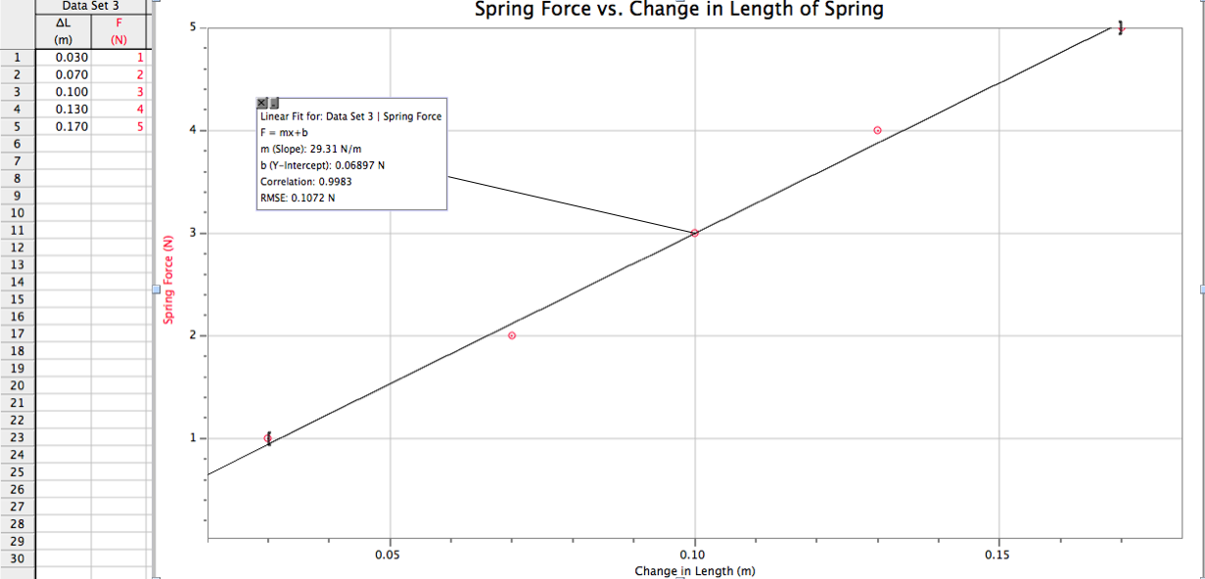
Analysis of Data:

Calculation of Spring Constant from graph of Spring Force vs. Change in Length of Spring:
F_{sp} = (29.31 N/m) Δ L

Slope = Spring Constant k= 29.31 N/m
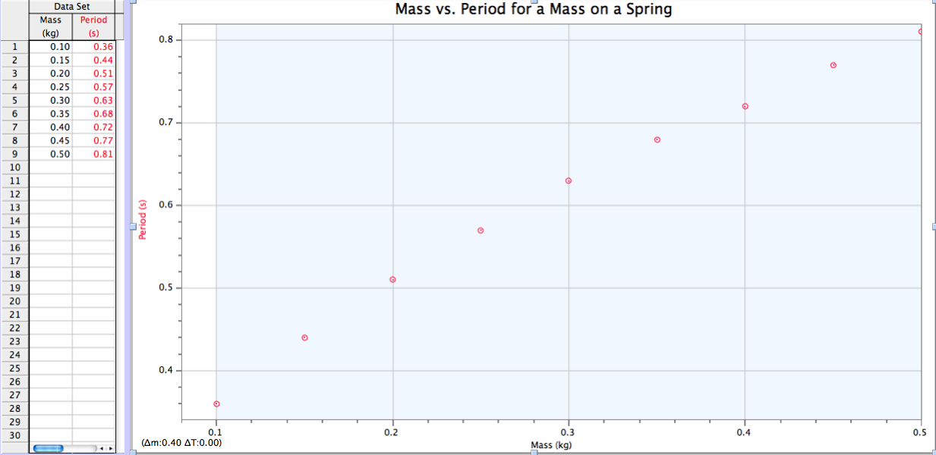
Our graph appears to be a side-opening parabola. In order to find the equation of the line, a test-plot was made of Period² vs. Mass.

Table 3. Mass vs. Period Squared Test Plot
Mass (kg) | Average  Period (s)
0.10 | 0.36
0.15 | 0.44
0.20 | 0.51
0.25 | 0.57
0.30 | 0.63
0.35 | 0.68
0.40 | 0.72
0.45 | 0.77
0.50 | 0.81

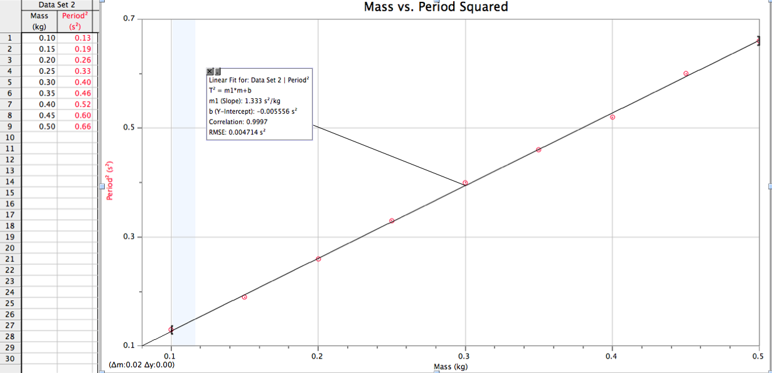
Since the resulting test plot is a direct proportion, our prediction is confirmed. Because the calculated intercept of -0.0056 s² is less than 5% of the highest value, we omitted it from the equation. The resulting mathematical model is: Period² = (1.33 s²/kg) · Mass.

Conclusion:
We learned that period of a square of the period of a pendulum is proportional to the mass hanging on the end as it oscillates in simple harmonic motion. As the mass on the end of the spring increases, the period-squared increases proportionally. The equation for our experiment was

Period² = (1.33 s²/kg) · Mass.

We assume that this relationship must also depend on the spring constant of the spring that was used for each trial. In order to ascertain the significance of the slope, the experiment must be extended to include an analysis of the relationship between the spring constant and the period of the oscillations. If the equation is rearranged, however, it can be seen that the period could depend on the square root of the mass and also the spring constant we calculated, if a term of 2∏ is included to account for the periodic motion of the oscillating spring. This would show that the general form of the equation would be:

which is shown to be equivalent by inserting a data point

Therefore, the slope of the equation is related to the periodic motion of the mass and the inverse of the spring constant. The intercept is not significant as it was less than 5%, and because as the mass on the end of the spring approaches zero, the force driving the oscillation (gravity pulling down on the mass and the resisting spring force in opposition) also approaches zero, and thus its period-squared also gets smaller and approaches zero.
There were several possible sources of error in this lab. First, the measurement of a single period requires precise selection on the graph on screen, but to minimize this error, we took an average of 3 trials of ten swings. Second, our system is did have some friction that caused a damping of the energy in the system, which could affect the length of the period for each subsequent oscillation. Third, our measurements could have been off when calculating the spring constant of the spring. Careful measurements of the change in length of the spring and time are essential to minimizing error in this lab.

