Pre AP Homework #1
Kinematic Equations

1. An automobile travels on a straight road for 40 km at 30 km/h. It then continues in the same direction for another 40km at 60km/h. a) What is the average velocity of the car during this 80 km trip? b) What is the average speed.

2. While driving home from school you travel at 95 km/h for 130 km then slow to 65 km/h. You get home in 3 hours and 20 min. How far is your hometown from school and what is the average speed?

3. You jog at 6 mi/h for 5 mi, then you drive another 5 mi in a car. With what average speed must you drive if your average speed for the entire 10 miles is to be 10.8 mi/hr?

4. A car accelerates at a rate of 0.6 m/s². How long does it take for this car to go from a speed of 55 mi/h to 60 mi/h?

5. A jet acquires a lift-off speed of 112 m/s in 20.0 s, starting from rest and traveling due east. What are the magnitude and direction of its average acceleration?

6 The position-time graph below represents the motion of South's basketball coach during the last sixteen seconds of overtime during this past weekend's game.
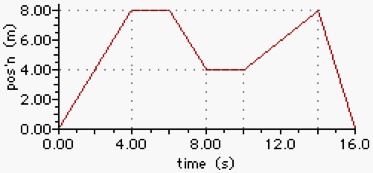

Use the graph on the other to answer the next several questions.
a. Determine the total distance walked by the coach during these 16 seconds.
b. Determine the resulting displacement of the coach during these 16 seconds.
c. Determine the displacement of the coach after 12.0 seconds.
d. At what time did the coach have the greatest displacement from his starting position?
e. What was the fastest speed which the coach walked during any of the time intervals for the last 16.0 seconds?
f. What was the average speed of the coach for these 16.0 seconds?

7. A biologist runs in a straight line toward his car at a speed of 4.0 m/s. The car is a distance d away. A hungry bear is 23 m behind the biologist and chases him at 6.0 m/s. The biologist reaches the car safely. What is the maximum possible value for d?

8. After a refueling stop a race car accelerates at 6m/s², and after 4 s reenters the raceway. At that instant, another race car traveling at a constant speed of 70 m/s overtakes and passes the refueled car. If the refueled car maintains its acceleration, how much time is required for it to catch the other car?

9. A sprinter starting a 100-yard race accelerates from rest at 9 ft/s². After acquiring top speed, he runs at constant speed. If he finishes in 11s, how far does he run while accelerating?

10. Two sprinters finish with times of 3:53.58 and 3:55.66. Assuming that both run 1609 m at constant velocity,, what distance separates them at the end of the race?

