**AP Physics Unit 1**

Physics Tool Kit

|  |  |  |  |
| --- | --- | --- | --- |
| **Day** | **In Class** | **Reading** | **Assignments** |
| 8/22/16 | Policies, Intro, Coin Lab | Syllabus/Disclosure | U1 Quiz 1 |
| 8/23/16 | Pre-Test  Choose Project Labs | Sections 1.3, 1.4 | Signed Document Due: 8/25 |
| 8/24/16 | Units & Dimensions  Dimensional Analysis | Sections 1.5 | *Problem Set 1-1 Due 8/29  Ch. 1: 9, 11, 14, 18, 29, 57 |
| 8/25/16 | Graphing, Function Recognition | Experimental Design & Graphical Analysis | U1 WS 1: Graphing Practice |
| 8/26/16 | Lab 1-1: Graphing & Analysis |  | Lab 1-1 |
| 8/29/16 | Error in Calculations | Reliability of Measurements | U1 WS 2: Error Calculations |
| 8/30/16 | Estimation |  | *Problem Set 1-2 Due 9/2  Ch. 1: 31, 33, 59, 62, 63 |
| 8/31/16 | Lab 1-2: Introduction of Laboratory Hardware |  | Lab 1-2 |
| 9/1/16 | Quiz 2, Review |  | Project Labs Due |
| 9/2/16 | Intro Unit Exam |  | HW turned in during Test |

**\*NOTE: Problem Sets from the textbook are from the section labeled “Problems” and NOT the “Concepts and Principles” or “Conceptual Questions” sections!**

**AP Physics Unit 1**

Physics Tool Kit

**Unit 1 Objectives:** Upon completion of Unit 1, you should be able to:

1. Recognize and write the International System (SI) units, with proper prefixes, for mass, length, and time. (Serway/Jewett, Section 1.1)

2. Given an equation and the SI units of all quantities, determine whether or not the equation is dimensionally consistent. (Serway/Jewett, Section 1.3)

3. Use the inside back cover of your text to convert one derived SI unit to another. (Serway/Jewett, Sec. 1.4)

4. Make rapid order of magnitude estimates, and calculate percentage uncertainty. (Serway/Jewett, Sec. 1.5)

5. Use appropriate methods of experimental design, and use graphing skills to find mathematical models and relationships. (Handout)

**Introductory Reading**

**Graphical Methods**

One of the most effective tools for the visual evaluation of data is a graph. The investigator is usually interested in a quantitative graph that shows the relationship between two variables in the form of a curve.

For the relationship y = f(x), x is the independent variable and y is the dependent variable. The rectangular coordinate system is convenient for graphing data, with the values of the dependent variable y being plotted along the vertical axis and the values of the independent variable x plotted along the horizontal axis.

Positive values of the dependent variable are traditionally plotted above the origin and positive values of the independent variables to the right of the origin. This convention is not always adhered to in physics, and thus the positive direction along the axes will be indicated by the direction the arrow heads point.

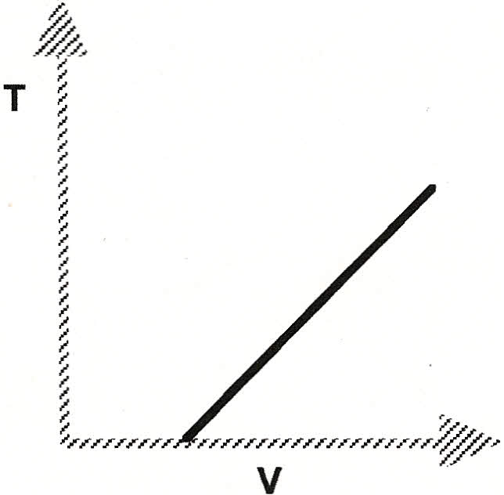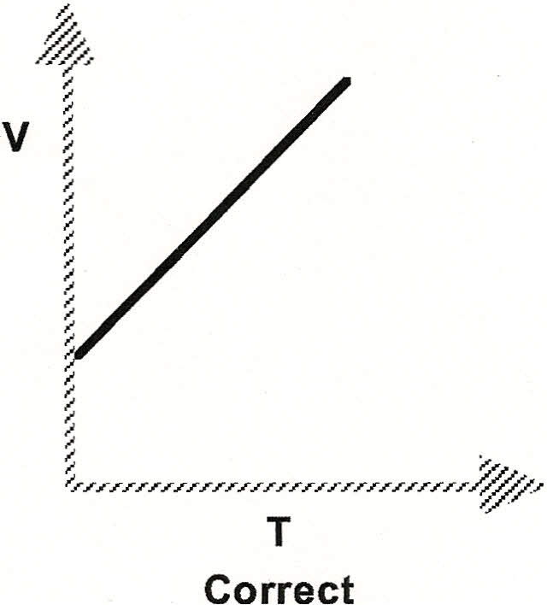The choice of dependent and independent variables is determined by the experimental approach or the character of the data. Generally, the independent variable is the one over which the experimenter has complete control; the dependent variable is the one that responds to changes in the independent variable. An example of this choice might be as follows. In an experiment where a given amount of gas expands when heated at a constant pressure, the relationship between these variables, V and T, may be graphically represented as follows:

**Incorrect**

By established convention, it is proper to plot V = f (T) rather than T = f (V), since the   
experimenter can directly control the temperature of the gas, but the volume can only be changed by changing the temperature.

However, also by convention, time is usually plotted on the x-axis when measuring position and speed or velocity. This is because we are used to talking about speed in miles per hour (mi/hr), or meters per second (m/s). The following page will discuss more about why we graph it this way.

**Curve Fitting**

When checking a law or determining a functional relationship, there is good reason to believe that a uniform curve or straight line will result. The process of matching an equation to a curve is called curve fitting. The desired empirical formula, assuming good data, can usually be determined by inspection. There are other mathematical methods of curve fitting, however they are very complex and will not be considered here. Curve fitting by inspection requires an assumption that the curve represents a linear or simple power function.

If data plotted on rectangular coordinates yields a straight line, the function y = f(x) is said to be *linear* and the line on the graph could be represented algebraically by the slope-intercept form:   
 y=mx+b,

where m is the slope and b is y-intercept.

Consider the following graph of position vs. time:

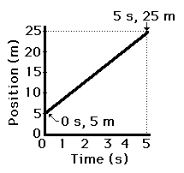

The curve is a straight line, indicating that x = f(t) is a linear relationship. Therefore,   
 **x** = m**t** + b,

where slope = 

From the graph, 

The curve intercepts the x-axis at x = 5 m*.* This indicates that the position was 5 m when the first measurement was taken; that is, when t = 0. Thus, b = x0 = 5 m*.*

The general equation, x = mt + b, can then be rewritten as

**x** = (4 *m/s*) t + 5 m.

This is also called a direct proportionality. As time increases, the position increases proportionally. They are said to be **directly related** to each other.

Consider the following graph of pressure vs. volume:



The curve appears to be a hyperbola (also called an inverse function). Hyperbolic or inverse functions suggest a test plot be made of P vs. . The resulting graph is shown below:



The equation for this straight line is



Where b = 0. Therefore,  when rearranged, this yields PV = constant, which is Boyle’s gas law.

This is called an inverse proportionality, because as one variable increases, the other decreases. The variables are said to be **inversely related**.

Consider the following graph of distance vs. time:



The curve appears to be a top-opening parabola. This function suggests that a test plot be made of d vs. t2. The resulting graph is shown below:



Since the plot of d vs. t2 is linear, then

**d** = m**t2** + b

The slope, m, is calculated by 

Since the curve passes through the origin, b = 0. The mathematical expression that describes the motion of the object is

.

Because the time on the x-axis is squared, we say that distance is **proportional to the square** of time.

Consider the following graph of distance vs. height:



The curve appears to be a side-opening parabola. This function suggests that a test plot be made of d2 vs. h. The resulting graph is shown below.



Since the graph of d2 vs. h is linear, the expression is

**d2** = m**h** + b.

The slope, m, is calculated by .

Since the line passes through the origin, b = 0. The mathematical expression is then

**d2** = (0.50 cm) **h**.

Because the distance on the y-axis is squared, we say that distance **squared is** **proportional to** height.

AP Physics Unit 1: Physics Toolkit

Worksheet 1: LoggerPro Practice Graphing Relationships

For the first 3 data sets:

Plot the points on LoggerPro and label the axes. Determine what type of relationship is modeled and manually linearize the data. Create the new test plot and determine the equation from the second graph.

1. Suppose you had measured the position of a Hot Wheels car at 3-second intervals and obtained the following data.

**Time (s) Position (m) Equation: __________________________**

3.00 1.60

6.00 7.40

9.00 21.8

12.0 41.2

15.0 66.8

18.0 96.2

2. Suppose you had measured the pressure as you reduced the volume of a gas and obtained the following data. Find the equation that models the data.

**Volume (cm3) Pressure (atm) Equation: __________________________**

31.2 1.02

27.9 1.07

24.1 1.19

24.1 1.19

20.8 1.39

17.6 1.68

15.2 1.91

14.0 2.01

3. Suppose you dropped a bowling ball from various heights, and measured its velocity just before it hit the ground. You would obtain the following data. Find the equation that models the data.

**Height (m) Velocity (m/s) Equation: ________________________**

0.250 0.812

0.500 1.12

1.00 1.48

1.30 1.75

1.80 2.04

2.40 2.31

3.00 2.53

For questions 4-6:

Plot the data points on LoggerPro and label the graphs. You may use the curve fit function to determine the equation, but take care that you **plot the variables on the correct axes** for the situation! (They aren’t necessarily in the correct order)

4. A force is measured at several different distances from a point and the data is shown below. Sketch the initial graph below and find the equation for the relationship.



Equation: __________________________________

5. A ball is dropped from rest at t = 0 seconds. Find a value for the acceleration due to gravity using the data below. (Hint: Remember the kinematics equation!)



Equation: ___________________________________ g from graph: ________________

6. The distance of a car from a given point is measured every second for six seconds. The car is traveling in a straight line. Sketch the graph, and give the value for the initial position, initial speed, and acceleration of the car using the data below. (Hint: remember the kinematics equation!)



Equation: _______________________________ Initial Position: _____________________

Initial speed: ___________________ Acceleration: _______________________

**AP Physics Unit 1: Physics Toolkit**

**Worksheet 2: Practice Error Calculations**

(Show all work)

1. In a series of measurements the values for the height of a table was measured 7 times with a meter stick. The measurements were taken by different persons and on different parts of the table. The values in meter units were: 1.05, 1.02, 1.10, 1.02, 1.07, 1.00, and 1.05. If the accepted value for the table height is 1.05 m, express the average value and its percent error.

2. A team of three lab partners measured the time of fall for a ball to be 4.2 s, 3.7 s, and 3.9 s. Assuming that you do not have a good reason to throw out any of the measurements, report the average value and an estimate of absolute error. Explain how you arrived at the answer.

3. What is the percent and absolute error associated with a measurement which gives a value of 10.6 m for a known length of 9.6 m?